

A PROJECT REPORT ON

ONLINE SHOES WEBSITE
(StepUp Footwear)
SUBMITTED AS A PARTIAL REQUIREMENT FOR
BACHELOR OF COMPUTER APPLICATION
(SEMESTER V)
YEAR 2026-27
GROUP NO.: 129
SUBMITTED BY:  1. Shubham Ashish Pancholi — Roll No. 3382 | GUIDED BY:  Minal Desai
- Saumya Chaudhari — Roll No. 3235
- Vrushank Changawala — Roll No. 3234

INDEX

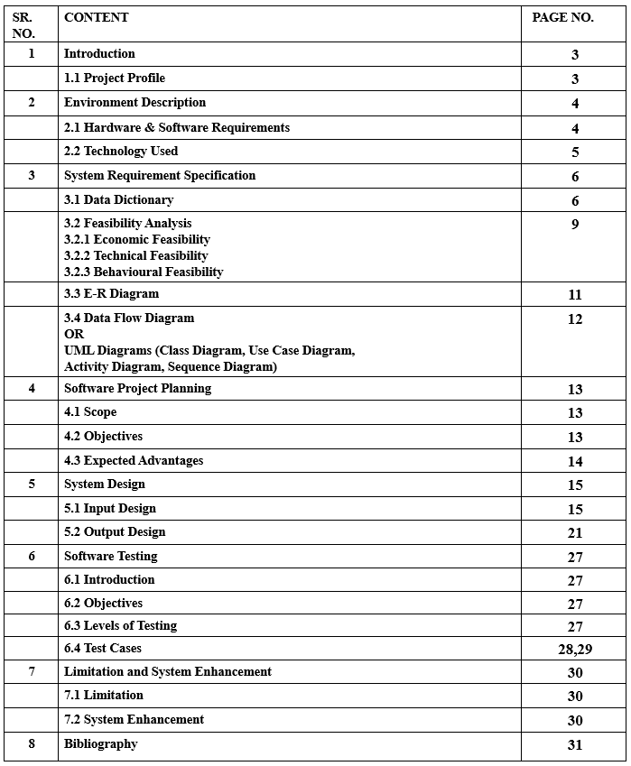

1 INTRODUCTION

The footwear market is growing rapidly with diverse choices ranging from everyday casual sneakers to high-performance running and sports shoes. In conventional shoe stores, customers have to travel physically to the retail shop, spend time searching through crowded racks, and often face disappointment due to non-availability of their required shoe size or preferred brand model. Moreover, managing customer inquiries, physical stock registers, order receipts, and paper billing creates heavy manual work for retail store owners.
To solve these real-world problems, this project titled "Online Shoes Website" (StepUp Footwear) has been developed as an e-commerce platform for BCA Semester 5 (AWD). It offers a centralized web portal where customers can browse shoes from leading brands like Nike, Adidas, Puma, Converse, Skechers, Woodland, and Clarks, view detailed specifications, select shoe sizes, manage their cart and wishlist, and place orders with online payment. An independent administrator panel allows store staff to manage product inventory, categories, brand listings, customer orders, and customer reviews efficiently.

1.1 Project Profile
The general overview and key parameters of the project are outlined in the table below:
Project Title | Online Shoes Website (StepUp Footwear)
Subject | Advanced Web Development (AWD) — BCA Semester 5
Academic Year | 2026 - 2027
Project Type | Full-Stack E-Commerce Web Application
Front-End Technologies | React.js (Vite), React Router DOM v6, Context API, CSS3
Back-End Technologies | Node.js, Express.js (REST API Architecture)
Database | MongoDB (Mongoose ODM) — awd_shoes_db
Payment Gateway | Razorpay Online Payment Integration
Security & Auth | JSON Web Tokens (JWT), Bcrypt.js Password Encryption, SVG Security CAPTCHA
Target Audience | Footwear retail customers, sports shoe enthusiasts, and store management staff
Submitted By | Shubham Ashish Pancholi (Roll No. 3382)  Saumya Chaudhari (Roll No. 3235)  Vrushank Changawala (Roll No. 3234)
Guided By | Minal Desai

2 ENVIRONMENT DESCRIPTION

The environment description outlines the technical setup, hardware requirements, and software stack used to develop and execute the Online Shoes Website.

2.1 Hardware & Software Requirements

2.1.1 Hardware Requirements
The hardware specifications needed to run the client and server components smoothly are listed below:
Processor: Intel Core i3 / AMD Ryzen 3 or higher.
Memory (RAM): Minimum 4 GB RAM (8 GB recommended for running Node server and Vite client concurrently).
Hard Disk Storage: Minimum 500 MB free hard disk space for code files, dependencies (node_modules), and uploaded product images.
Display Resolution: 1366 × 768 pixels or higher for standard desktop and laptop screens.
Network / Internet: Active internet connection required for Google Fonts, brand logos, and Razorpay API communication.

2.1.2 Software Requirements
The software components, tools, and runtimes used in the development environment include:
Operating System: Microsoft Windows 10 / Windows 11 (64-bit).
Web Browser: Google Chrome (v115+), Microsoft Edge, or Mozilla Firefox with JavaScript enabled.
Runtime Environment: Node.js (v18.x, v20.x, or v24.x LTS).
Package Manager: npm (Node Package Manager) for managing project dependencies.
Database Engine: MongoDB Community Server (v6.x or v7.x) running locally on port 27017.
Database Management Tool: MongoDB Compass and MongoDB Shell (mongosh).
Code Editor / IDE: Visual Studio Code / Antigravity IDE.
Version Control: Git & GitHub repository for source code versioning.

2.2 Technology Used
The system is built on modern web development technologies following the MERN (MongoDB, Express.js, React, Node.js) full-stack paradigm:

1. React.js (Frontend User Interface)
React is an open-source component-based JavaScript library used for building interactive single-page user interfaces. In this project, React manages reusable UI components such as shoe product cards, navigation bars, brand carousels, and modal dialogs. Client-side routing is handled using react-router-dom (v6) allowing fast page transitions without page reloads.

2. Vite (Frontend Build Tool)
Vite provides an extremely fast local development server with Hot Module Replacement (HMR) and bundles optimized static production assets using Rollup.

3. Context API (State Management)
React Context API is used for global state management across the application:
AuthContext: Maintains user authentication status, user profile, and JWT token in localStorage.
CartContext: Handles cart items, shoe size selection, quantity adjustments, and total price calculation.
WishlistContext: Manages customer-saved favorite shoes for future shopping.

4. Node.js & Express.js (Backend REST API)
Node.js executes JavaScript on the server side using an asynchronous, event-driven engine. Express.js is a minimal and flexible web application framework that provides robust routing, JSON request parsing, and error-handling middleware for all API endpoints (e.g., /api/auth, /api/products, /api/orders, /api/categories).

5. MongoDB & Mongoose (Database & ODM)
MongoDB is a document-oriented NoSQL database that stores data in flexible JSON-like documents. Mongoose is used as the Object Data Modeling (ODM) library to enforce strict schemas, relationships, default values, and data validation rules for all entities.

6. Razorpay Payment Gateway
Razorpay provides an online checkout interface supporting UPI, Credit/Debit cards, Net Banking, and digital wallets for completing footwear purchases securely.

3 SYSTEM REQUIREMENT SPECIFICATION

This section presents the structural data requirements, feasibility study, Entity-Relationship model, and UML diagrams representing the Online Shoes Website.

3.1 Data Dictionary
The data dictionary documents the exact collections, field names, data types, constraints, and descriptions used in the MongoDB database (awd_shoes_db).

Table 1: User Collection (users)
Field Name | Data Type | Constraint | Description
_id | ObjectId | Primary Key | Unique MongoDB identifier for the user account
name | String | Required | Full name of the customer
email | String | Required, Unique | Email address used for authentication and communications
password | String | Required | Bcrypt-hashed encrypted account password
phone | String | Optional | Contact mobile number of the customer
address | String | Optional | Residential/shipping street address
role | String | Default: 'user' | Account privilege level ('user' or 'admin')
createdAt | Date | Auto-generated | Timestamp of account registration

Table 2: Product Collection (products)
Field Name | Data Type | Constraint | Description
_id | ObjectId | Primary Key | Unique MongoDB identifier for the shoe item
name | String | Required | Model name of the shoe (e.g. Nike Air Max)
brand | String | Required | Brand name (Nike, Puma, Adidas, Converse, etc.)
category | ObjectId | Required, FK | Reference to Category collection _id
price | Number | Required | Retail price in Indian Rupees (INR)
stock | Number | Required, Default: 10 | Available inventory stock quantity
sizes | Array of  Numbers | Default:  [6,7,8,9,10,11] | Available shoe sizes (UK sizing)
description | String | Required | Shoe specifications, material, and cushioning details
Field Name | Data Type | Constraint | Description
image | String | Required | File path / URL of product image in uploads folder
isFeatured | Boolean | Default: false | Flag to display shoe in Featured section on Home page

Table 3: Category Collection (categories)
Field Name | Data Type | Constraint | Description
_id | ObjectId | Primary Key | Unique MongoDB identifier for category
name | String | Required, Unique | Category title (Running, Casual, Sports, Formal,  Boots)
description | String | Optional | Short summary explaining footwear purpose

Table 4: Brand Collection (brands)
Field Name | Data Type | Constraint | Description
_id | ObjectId | Primary Key | Unique MongoDB identifier for brand
name | String | Required, Unique | Brand name (Nike, Adidas, Puma, Skechers, etc.)
slug | String | Optional | URL-friendly brand slug
logo | String | Optional | Relative path to brand vector logo icon
description | String | Optional | Short brand profile summary

Table 5: Order Collection (orders)
Field Name | Data Type | Constraint | Description
_id | ObjectId | Primary Key | Unique order tracking identifier
user | ObjectId | Required, FK | Reference to customer in User collection
items | Array of  Objects | Required | Ordered shoes: product ID, name, size, price, qty
shippingAddress | Object | Required | Full name, phone, street address, city, postal code
paymentMethod | String | Default: 'Razorpay' | Selected payment gateway
paymentStatus | String | Default: 'Pending' | Payment result ('Pending' or 'Paid')
razorpayPaymentId | String | Optional | Transaction ID issued by Razorpay upon success
Field Name | Data Type | Constraint | Description
totalAmount | Number | Required | Final invoice amount paid in INR
status | String | Default: 'Pending' | Fulfillment status: Pending, Processing,  Shipped, Delivered

Table 6: Review Collection (reviews)
Field Name | Data Type | Constraint | Description
_id | ObjectId | Primary Key | Unique review identifier
product | ObjectId | Required, FK | Reference to reviewed shoe product
user | ObjectId | Required, FK | Reference to reviewer customer account
userName | String | Required | Display name of customer
rating | Number | Required (1 to 5) | Customer star rating for comfort and quality
comment | String | Required | Written feedback and comments

Table 7: ContactMessage Collection (contactmessages)
Field Name | Data Type | Constraint | Description
_id | ObjectId | Primary Key | Unique message identifier
name | String | Required | Name of customer sending inquiry
email | String | Required | Reply email address
subject | String | Required | Inquiry subject topic
message | String | Required | Full inquiry text message

Table 8: Admin Collection (admins)
Field Name | Data Type | Constraint | Description
_id | ObjectId | Primary Key | Unique admin identifier
username | String | Required | Admin portal login username
email | String | Required, Unique | Admin contact and notification email
password | String | Required | Encrypted password for administrator credentials
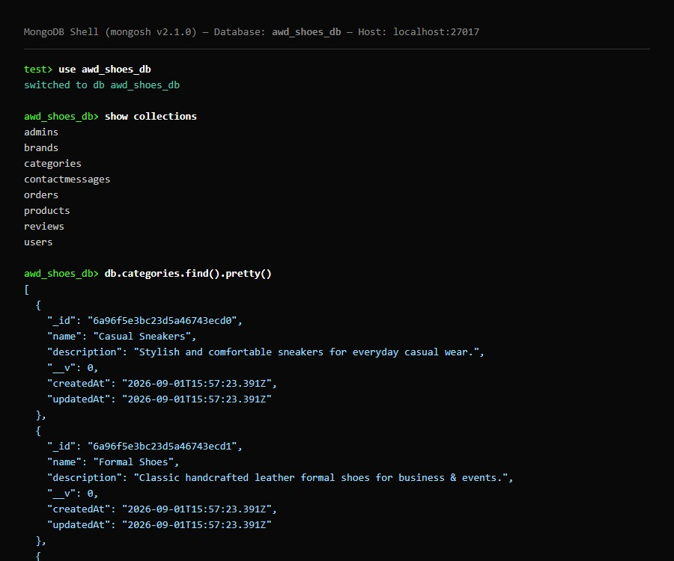
Figure 3.1: Actual MongoDB Database (awd_shoes_db) Shell & Collection View

3.2 Feasibility Analysis
A feasibility study is conducted to evaluate whether the proposed system can be successfully developed, implemented, and utilized within practical college project limits.

3.2.1 Economic Feasibility
Economic feasibility examines the financial investment needed to develop and operate the system:
Development Tools Cost: The entire technology stack (Node.js, Express, React, MongoDB, VS Code) is 100% free and open-source. No commercial licenses or proprietary tools were purchased.
Hardware Cost: Existing standard college lab computers and personal laptops were used for development without requiring specialized server hardware.
Operational & Maintenance Cost: Routine database backups and code updates can be performed with minimal computing resources. Cloud hosting platforms (such as Render, Vercel, and MongoDB Atlas) provide free tier options suitable for student projects.
Conclusion: The project has virtually zero monetary cost and is economically completely feasible.

3.2.2 Technical Feasibility
Technical feasibility determines whether the required technical skills and technologies are available:
MERN Stack Compatibility: Node.js, Express, MongoDB, and React work seamlessly together using JSON as a universal data exchange format.
Developer Skill Set: The team has acquired practical knowledge in HTML5, CSS3, JavaScript, React components, RESTful routing, and MongoDB querying through the BCA Semester 5 curriculum.
Reliability: MongoDB provides reliable document storage with atomic operations, and React provides responsive client-side state handling.
Conclusion: The project is technically sound and fully feasible.

3.2.3 Behavioural Feasibility
Behavioural feasibility assesses user acceptance and ease of learning:
Customer Acceptance: The website follows standard e-commerce layout conventions (search bar, cart badge, size selectors, clear checkout). Users require no prior training to shop.
Admin Usability: The admin dashboard has straightforward forms for adding shoes and updating orders without requiring technical database commands.
Conclusion: The system is user-friendly and behaviourally feasible.

3.3 E-R Diagram
The Entity-Relationship (E-R) diagram models the conceptual database architecture of the Online Shoes
Website. It defines the major entities (User, Product, Category, Brand, Order, Review, ContactMessage, Admin) and the cardinality of relationships between them.
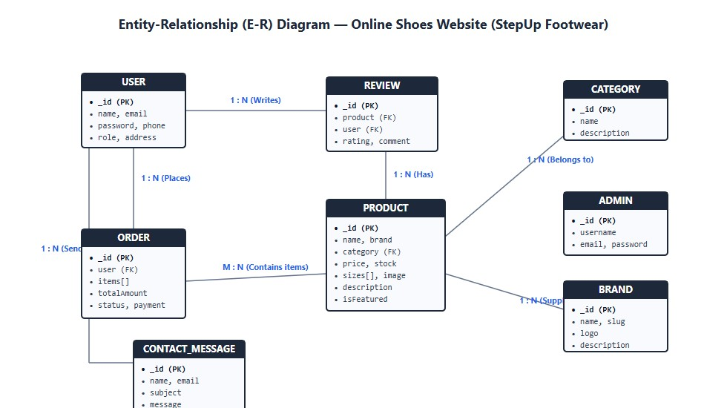

Figure 3.2: Entity-Relationship (E-R) Diagram of Online Shoes Website
Relationship Explanations:
User — Order (1 : N): A single registered customer can place multiple shoe orders over time.
Each order belongs strictly to one customer.
User — Review (1 : N): A customer can write multiple product reviews and ratings. Each review is linked to one user.
Category — Product (1 : N): Each shoe category (e.g. Running, Casual, Formal) groups multiple shoe models. Each shoe product belongs to one primary category.
Brand — Product (1 : N): A footwear brand (e.g. Nike, Puma, Adidas) manufactures multiple shoe products in the catalog.
Product — Review (1 : N): Each shoe item can receive multiple customer reviews and star ratings.
Order — Product (M : N via Order Items): An order can contain multiple pairs of shoes of various sizes, and a shoe product can be part of many customer orders.
User — ContactMessage (1 : N): A customer can submit multiple support inquiries or messages.

3.4 UML Diagrams
Unified Modeling Language (UML) diagrams provide standard visual representations of system actors, use cases, classes, and workflows.

3.4.1 Use Case Diagram
The Use Case diagram identifies the primary actors (Customer and Store Administrator) and their direct interactions with the system modules.
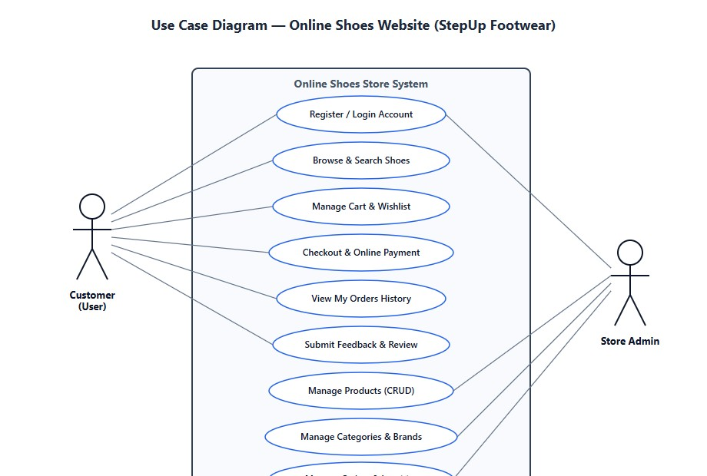
Figure 3.3: Use Case Diagram for Online Shoes Website

3.4.2 Class Diagram
The Class diagram models the object-oriented structure of the application, detailing the class attributes and member methods implemented across the models and controllers.

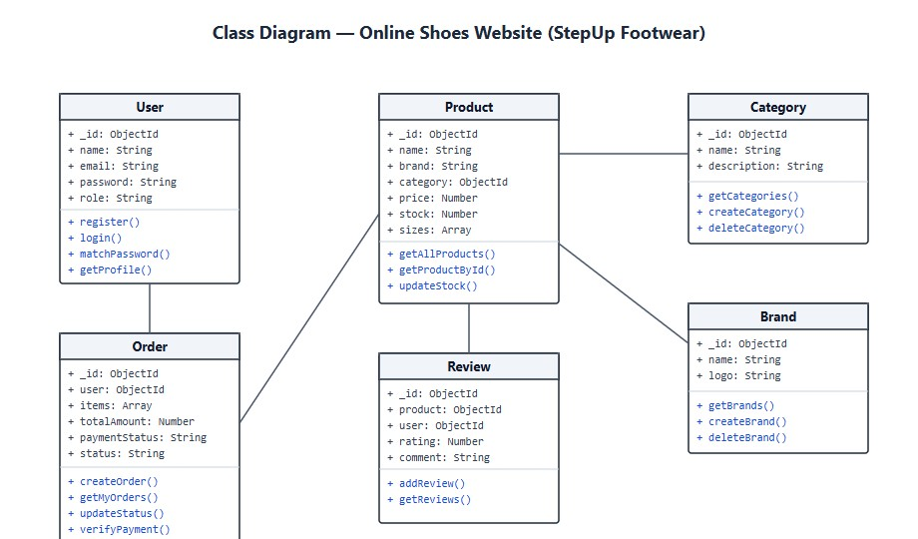

4 SOFTWARE PROJECT PLANNING

Software project planning defines the functional boundaries, core goals, and practical benefits expected from the Online Shoes Website.

4.1 Scope
The scope of the Online Shoes Website encompasses full e-commerce operations tailored for footwear retail:
Customer Account Management: Account registration, secure login with security CAPTCHA, profile management, and order history view.
Catalog Exploration: Real-time shoe search by model name, category-based filtering, brandbased filtering, and price range sorting.
Product Details & Sizing: Detailed shoe descriptions, multi-angle images, available stock counts, and UK shoe size selection (Sizes 6 to 11).
Cart & Wishlist: Real-time cart calculation with quantity increment/decrement, persistent wishlist storage, and item removal.
Checkout & Payment: Delivery address collection and online payment integration via Razorpay.
Customer Feedback: Star ratings (1 to 5 stars) and comments on shoe performance and fit.
Independent Administrator Portal: Isolated admin dashboard displaying live order metrics, product management (add/edit/delete shoes), category management, brand listings, order fulfillment status updates, and user inquiry reviews.

4.2 Objectives
The primary objectives of developing the Online Shoes Website are:
To replace traditional paper-based shoe sales registers with an automated database.
To provide customers with 24/7 access to browse and purchase shoes from anywhere.
To provide transparent shoe sizing information and accurate stock availability.
To streamline order tracking so customers can check order progress (Pending, Processing, Shipped, Delivered).
To secure customer data using industry-standard password hashing (Bcrypt) and stateless token authentication (JWT).
To prevent bot attacks on login and registration through mathematical/alphanumeric CAPTCHA verification.
To give store managers an easy-to-use admin console for inventory and sales oversight.

4.3 Expected Advantages
The practical advantages of the implemented system include:
Time Efficiency: Customers save travel time and can place shoe orders in less than two minutes.
Reduced Human Error: Automated bill calculation eliminates arithmetic errors in subtotals and discounts.
Real-Time Inventory Control: Stock counts update immediately upon order placement, preventing overselling.
Better Customer Engagement: Real customer reviews and star ratings build trust and help shoppers pick the right shoes.
Centralized Data Storage: All orders, customer details, and product catalogs are safely stored in MongoDB with simple backup capabilities.

5 SYSTEM DESIGN

System design covers the input forms through which users supply information to the system and the corresponding output interfaces displayed to users and administrators.

5.1 Input Design
Input design ensures that data entered into the system is accurate, validated, and user-friendly. Real screenshots of the implemented input forms are provided below:

1. Customer Sign In Form
The customer login form requires an email address, password, and security CAPTCHA verification. Form inputs are pre-filled with demo credentials for easy faculty evaluation.
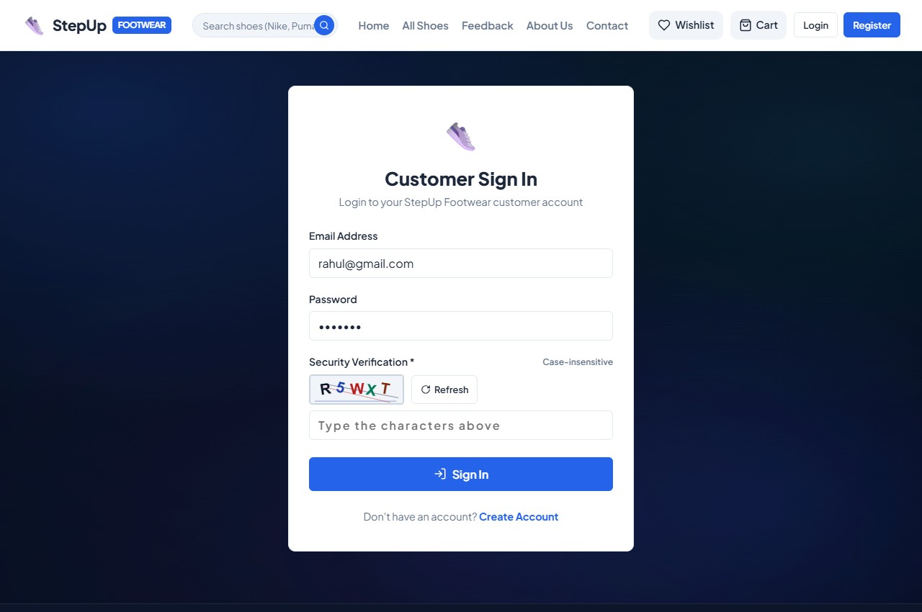
Figure 5.1: Customer Sign In Form with CAPTCHA

2. Customer Registration Form
Allows new customers to create an account by providing full name, email, contact phone, delivery address, password, and CAPTCHA.
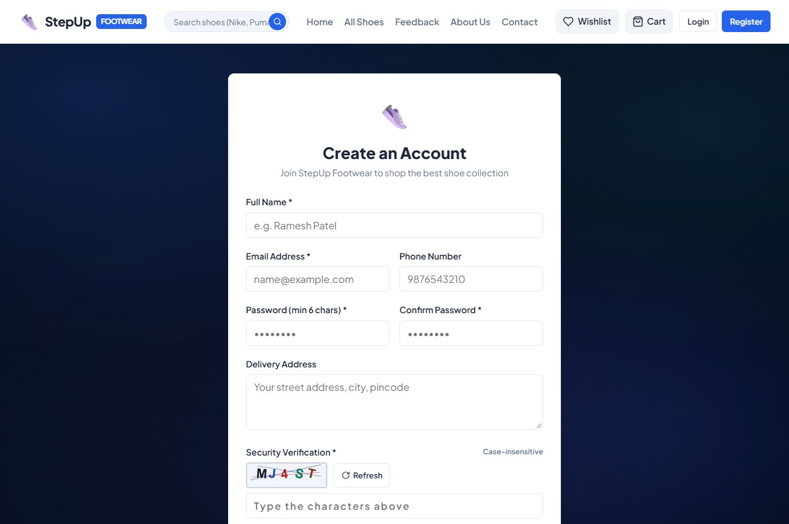
Figure 5.2: Customer Registration Form

3. Checkout & Delivery Address Form
Collects delivery recipient details (full name, phone, street address, city, and PIN code) and payment method selection before opening Razorpay checkout.
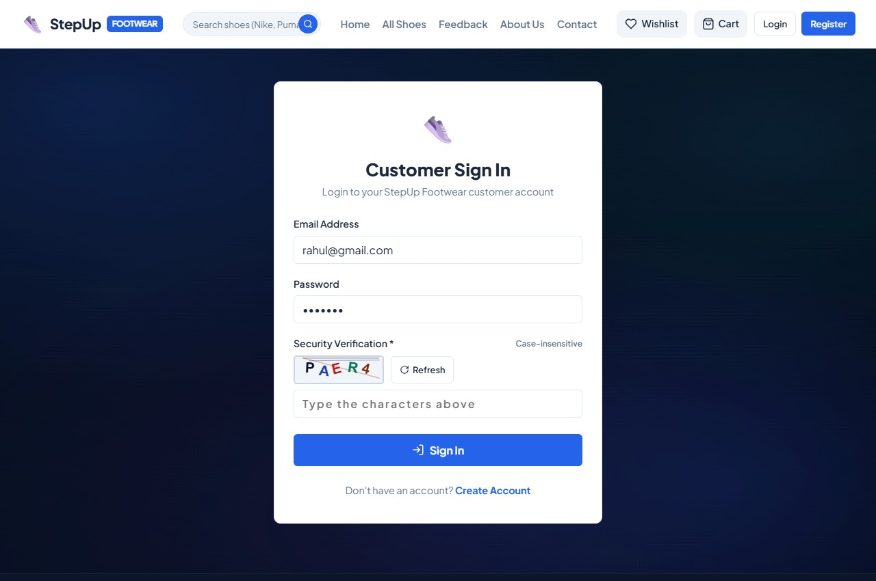
Figure 5.3: Checkout Delivery Address Form

4. Customer Feedback & Review Form
Enables customers to select a shoe product, submit a 1-to-5 star rating, and provide qualitative feedback.
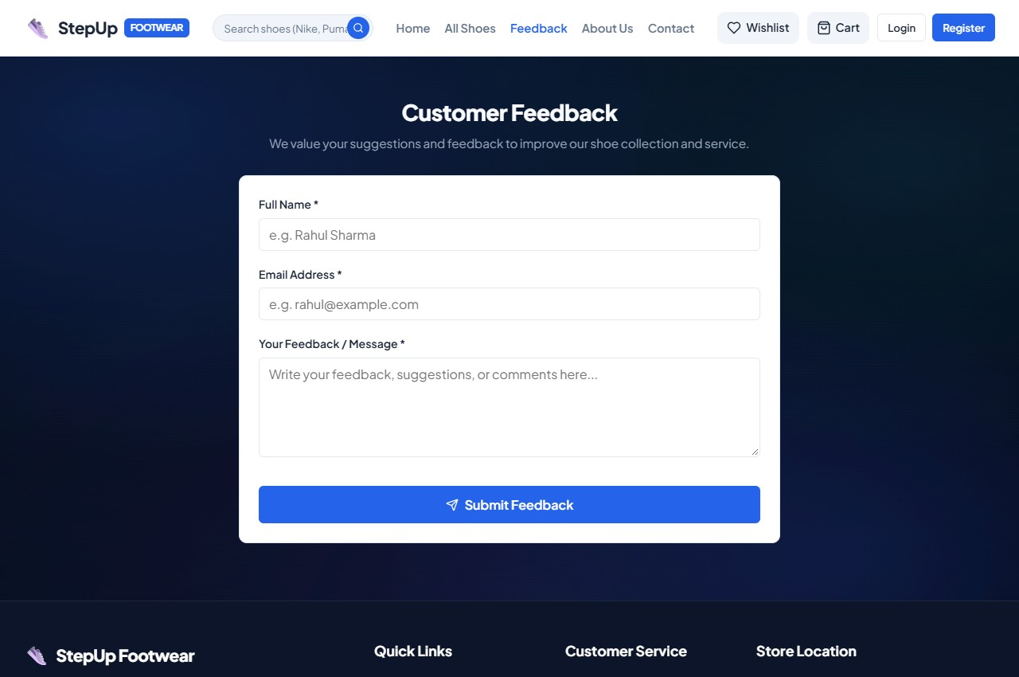
Figure 5.4: Customer Feedback & Review Form

5. Contact Support Form
Provides a direct channel for customer inquiries regarding sizing, bulk orders, or shipment delays.
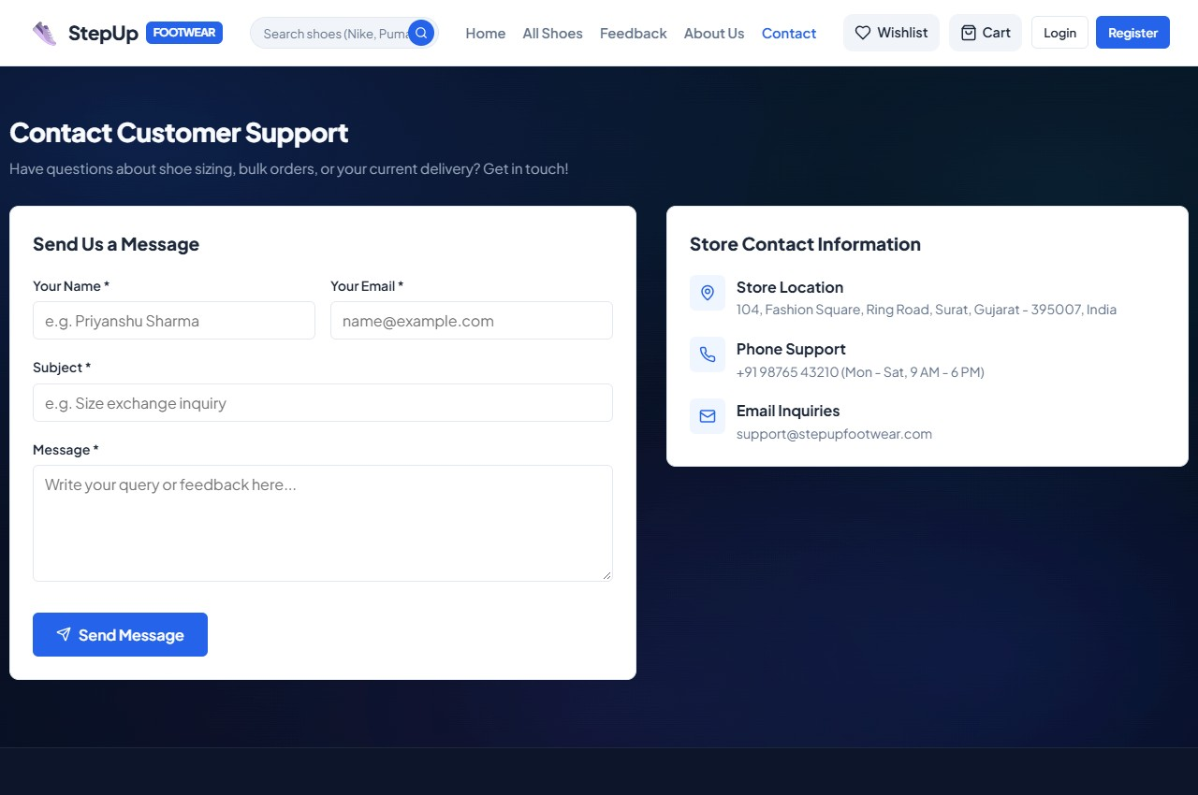
Figure 5.5: Contact Support Inquiry Form

6. Administrator Login Form
Dedicated admin login screen isolated from the client website, featuring pre-filled admin credentials and CAPTCHA validation.
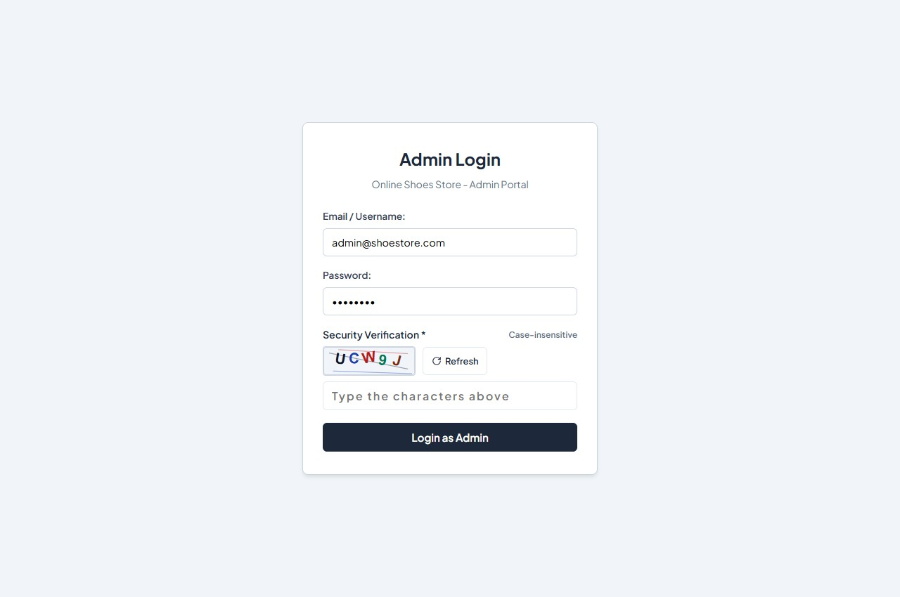
Figure 5.6: Dedicated Administrator Login Form

7. Admin Category Management Form
Allows administrators to create new footwear categories and edit existing category names and descriptions.
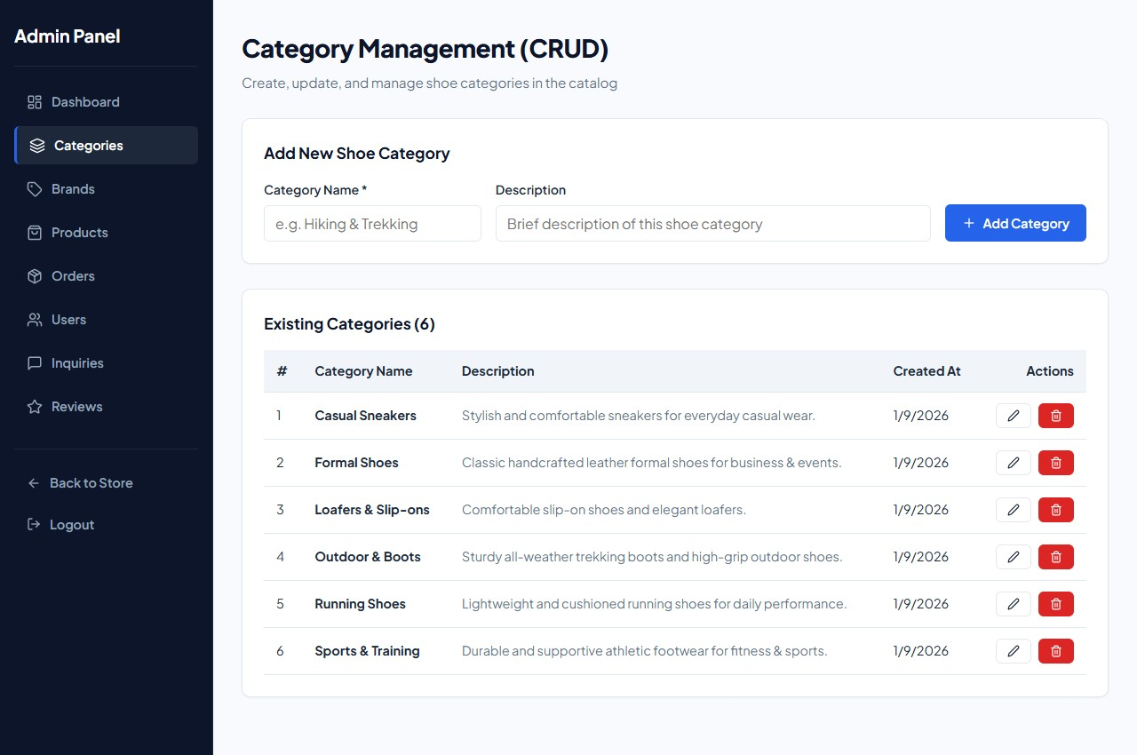
Figure 5.7: Admin Category Creation Form

8. Admin Shoe Product Form
Allows the store manager to add new shoe models with model name, brand, category, price, stock count, description, and image upload.
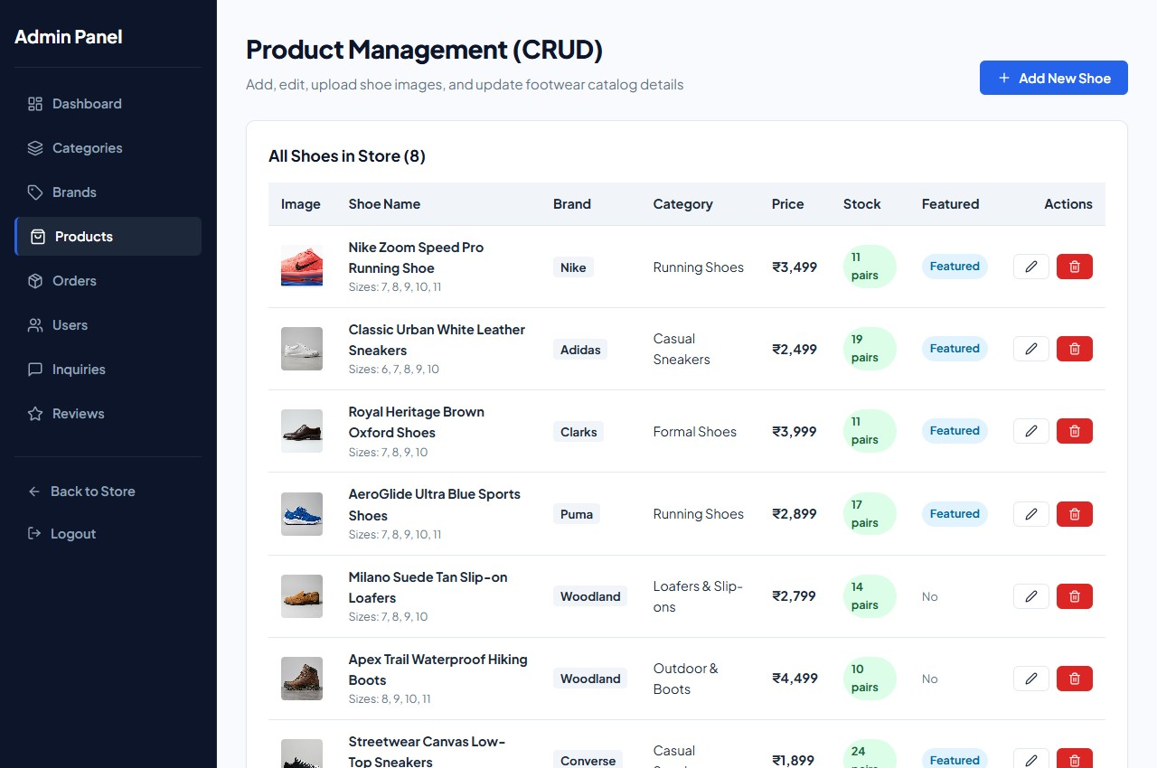
Figure 5.8: Admin Shoe Product Management Form

5.2 Output Design
Output design focuses on presenting information clearly and effectively to both customers and store administrators. Real screenshots of the output screens are presented below:

1. Home Page & Brand Marquee
Displays the store banner, featured footwear collections, brand logos (Nike, Puma, Adidas, Converse, Skechers), and special promotions.
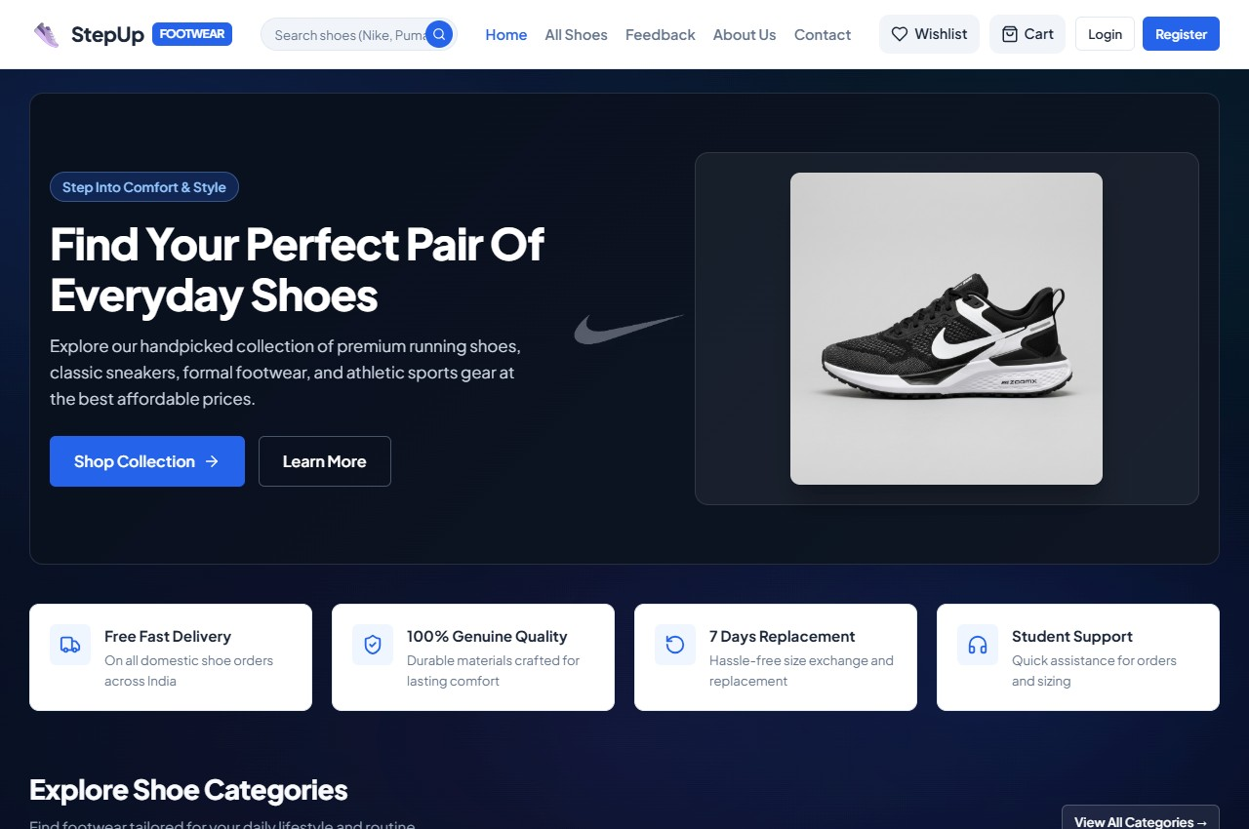
Figure 5.9: Home Page with Brand Showcase

2. All Shoes Catalog with Filters
Displays the full shoe catalog in a responsive grid with category filter tags, brand filter buttons, and search results.
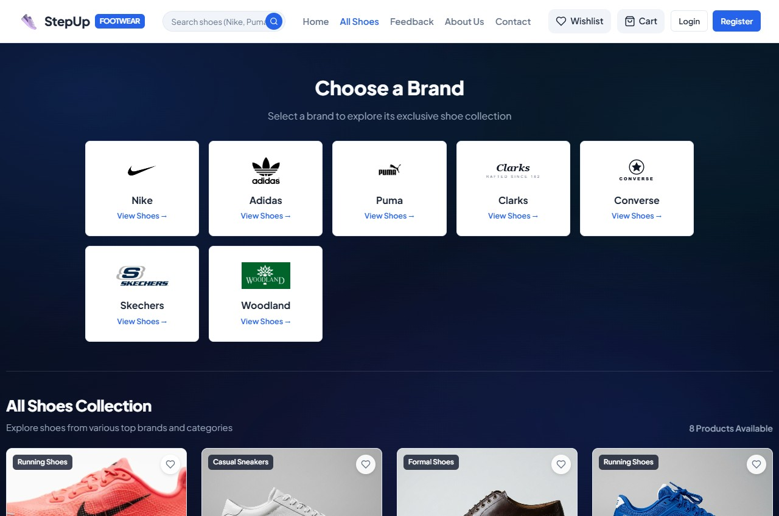
Figure 5.10: All Shoes Catalog with Filtering

3. Product Details Screen
Shows high-resolution shoe imagery, brand badge, retail price, stock status, available UK sizes (6 to 11), and "Add to Cart" / "Add to Wishlist" buttons.
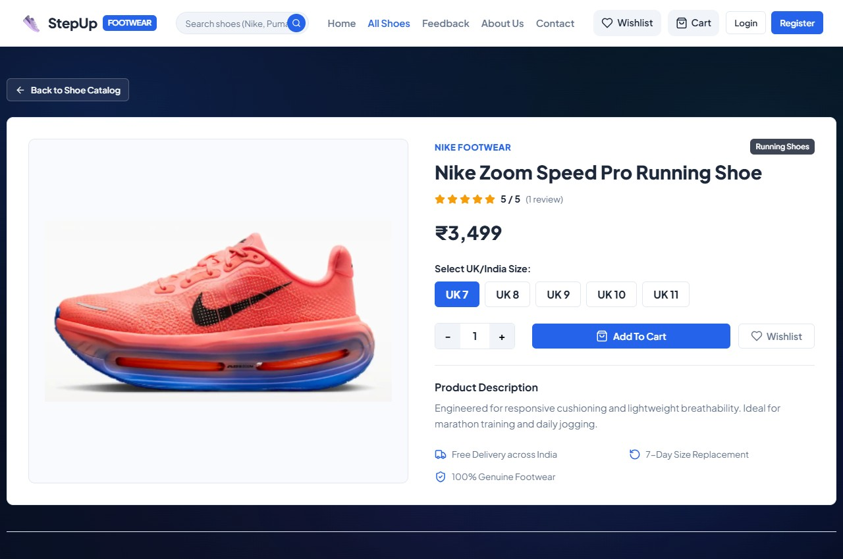
Figure 5.11: Shoe Product Details Screen

4. Shopping Cart Screen
Lists selected shoes, chosen sizes, item quantity adjusters, individual item subtotals, free delivery indicator, and "Proceed to Checkout" button.
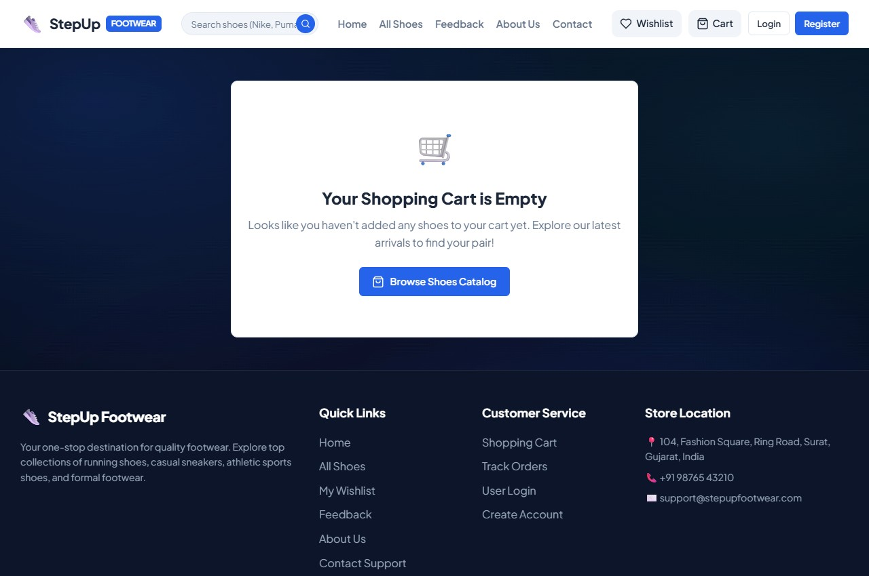
Figure 5.12: Shopping Cart Overview Screen

5. Admin Dashboard & Analytics
Provides store managers with real-time statistics on total products, active categories, total orders placed, and recent customer orders with serial indexes (#1, #2, #3).
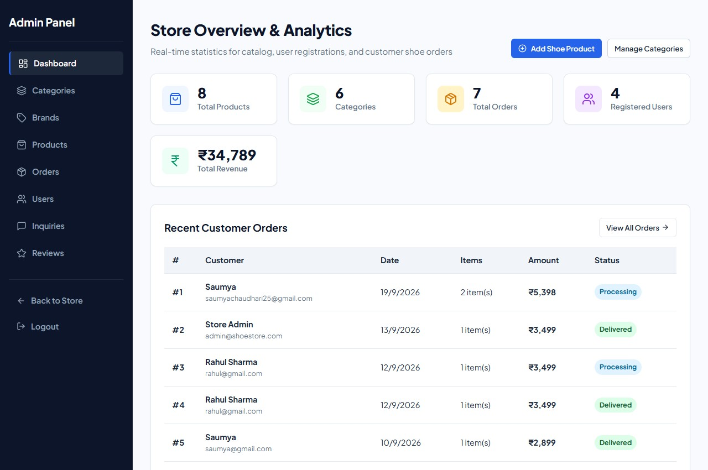
Figure 5.13: Admin Dashboard with Live Statistics

6. Admin Orders Management Screen
Displays all placed orders with customer details, order items, invoice amounts, payment status, and a status dropdown for updating order fulfillment.
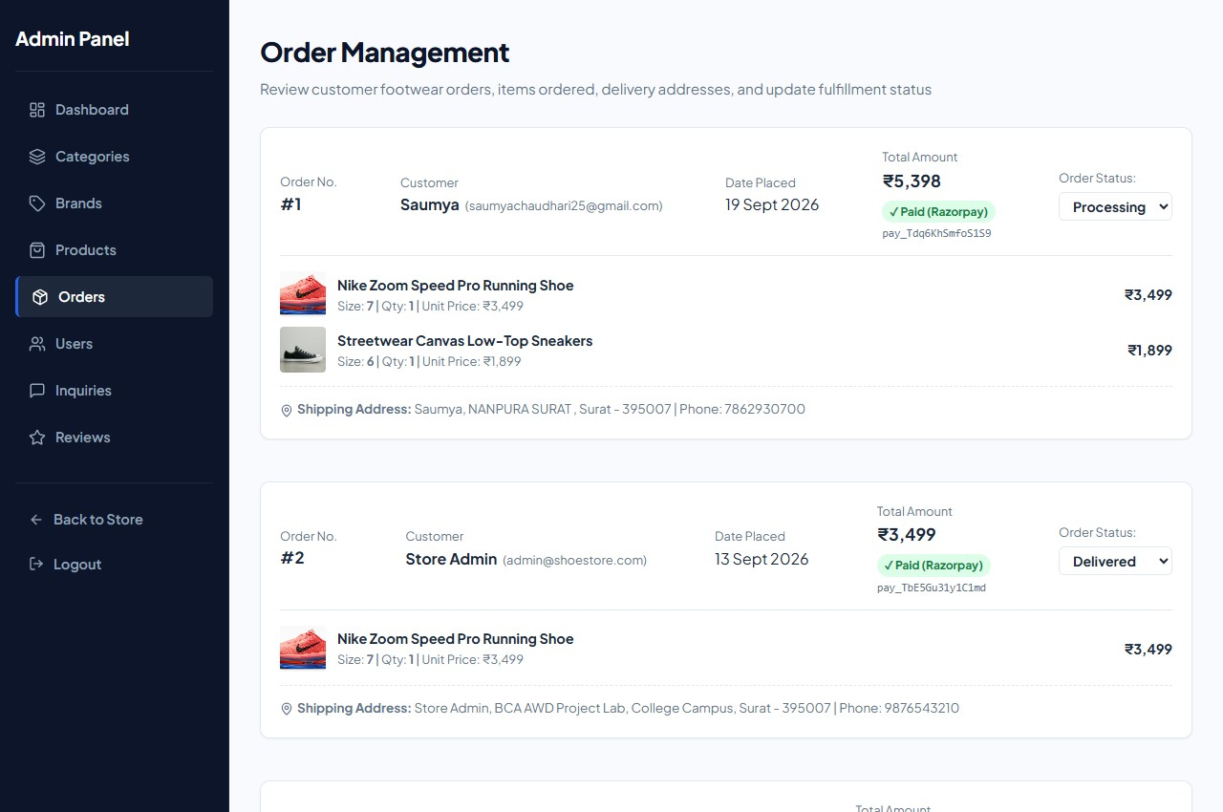
Figure 5.14: Admin Orders Fulfillment Screen

7. Admin Brands Management Screen
Shows all registered footwear brands, their logo representations, and associated product counts.
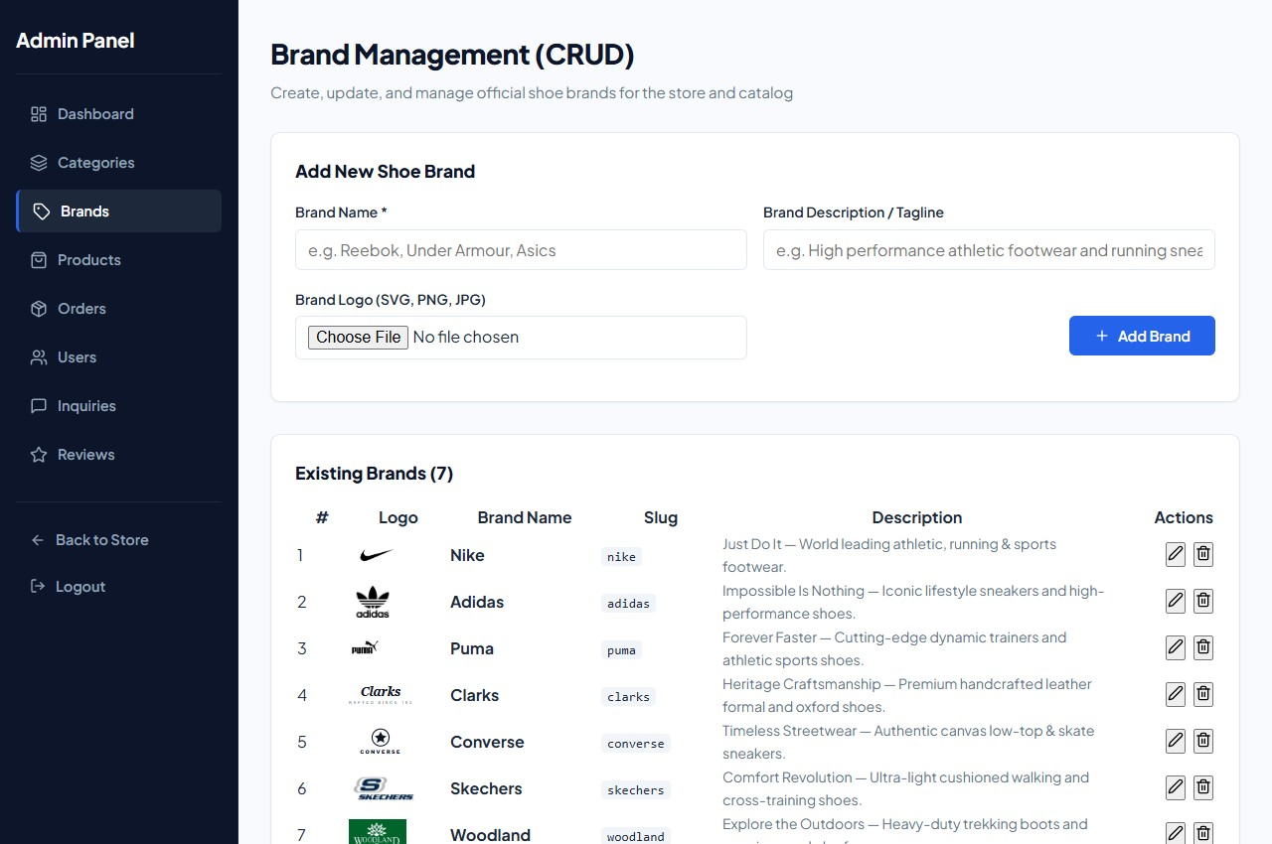
Figure 5.15: Admin Brand Management Screen

8. Admin Customer Inquiries Screen
Lists all contact messages received from website visitors with sender name, email, subject, and message content.
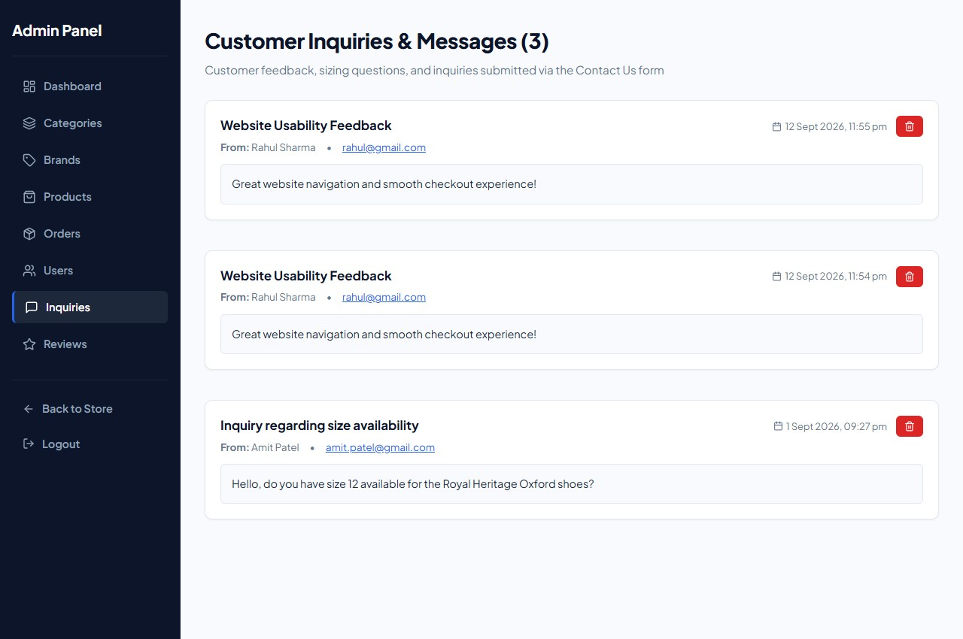
Figure 5.16: Admin Customer Inquiries Screen

9. Admin Shoe Reviews Screen
Displays customer reviews and star ratings with moderation controls for the store administrator.
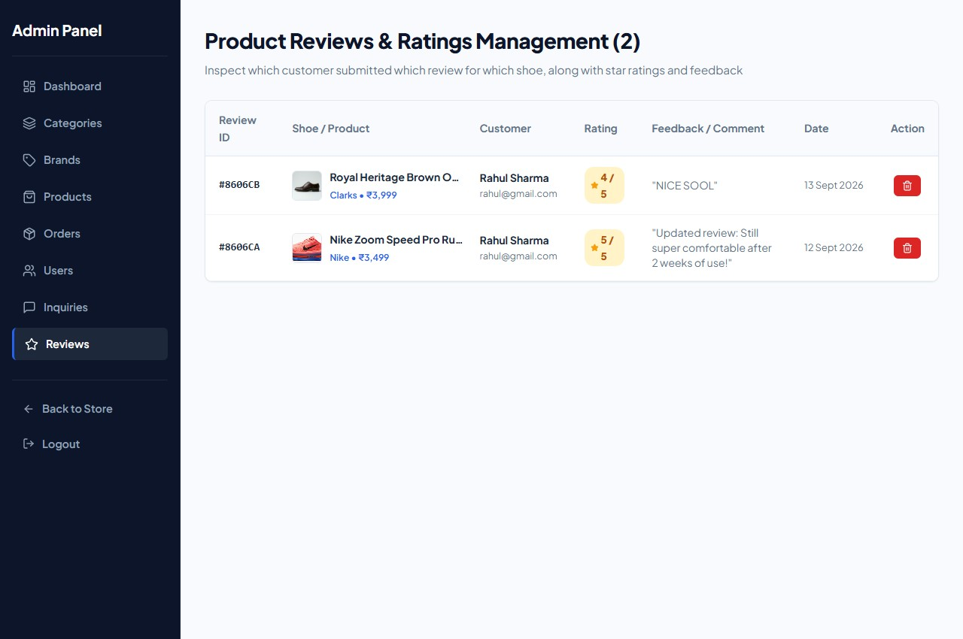
Figure 5.17: Admin Shoe Reviews Management Screen

6 SOFTWARE TESTING

6.1 Introduction
Software testing is a systematic process of executing application components with the intent of finding defects, verifying input validation rules, and confirming that all implemented features operate according to the project requirements. Testing ensures that the Online Shoes Website is reliable, secure, and userfriendly prior to deployment.

6.2 Objectives of Testing
The core objectives of testing this web application include:
To confirm that user registration, login, and CAPTCHA validation work correctly.
To verify that shoe search, category filtering, and brand navigation yield accurate results.
To check that shopping cart calculations (subtotal, quantity adjustments, and total payable) are accurate.
To test that Razorpay payment checkout triggers properly and records successful transactions.
To ensure that admin CRUD operations correctly update records in MongoDB.
To confirm that unauthorized visitors cannot access protected admin routes.

6.3 Levels of Testing
The testing strategy employed for this project comprises four standard levels:
1. Unit Testing: Individual modules, utility functions (e.g. CAPTCHA verification, password hashing, JWT token generation), and isolated React components were tested independently.
2. Integration Testing: Verified data flow between React frontend components and Express backend API routes, ensuring JSON payloads are received and processed correctly.
3. System Testing: The entire application was tested end-to-end (from user registration, shoe search, and cart addition to checkout and admin order status update) to ensure seamless workflow.
4. Acceptance / Usability Testing: Conducted with peers and group members to verify that navigation is simple, text is readable, and buttons respond promptly.

6.4 Test Cases
The table below documents 12 actual test cases executed on the Online Shoes Website:
TC ID | Feature Tested | Input / Action | Expected Result | Actual Result | Status
TC-01 | User Registration | Enter valid name, new email, password, address, and correct CAPTCHA | Account created, user logged in, redirected to home page | Account created, JWT stored in localStorage | PASS
TC-02 | Duplicate Email  Check | Register with an already existing email address | Error message: "User with this email already exists" | Displayed  error alert, registration prevented | PASS
TC-03 | Customer Login | Enter valid email (rahul@gmail.com), password (user123), and valid CAPTCHA | Successful login, customer name displayed in navbar | Logged in, redirected to store | PASS
TC-04 | Invalid Password  Login | Enter correct email with wrong password | Error message: "Invalid email or password" | Displayed 401 error message | PASS
TC-05 | Shoe Search | Type "Nike" in navbar search bar and press Enter | Products page displays only  Nike brand shoes | Filtered list  showing Nike shoe models | PASS
TC-06 | Category Filtering | Click on "Running" category badge | Display only shoes categorized under Running | Catalog updated to show running shoes | PASS
TC-07 | Add to Cart with  Size | Select UK Size 8 on product details and click "Add to  Cart" | Shoe added to cart with Size UK 8, cart count badge increments | Cart badge updated to 1, item saved in CartContext | PASS
TC-08 | Cart Quantity  Update | Click '+' button to increase shoe quantity to 2 | Subtotal doubles, total payable updates accurately | Amount updated immediately in cart table | PASS
TC-09 | Checkout  Validation | Leave shipping address empty and click Pay button | Browser HTML5 validation prompts user to fill required fields | Submission stopped, field highlighted | PASS
TC-10 | Razorpay Payment | Click "Pay with Razorpay" with valid delivery address | Official Razorpay modal popup opens with payment options | Razorpay checkout window | PASS

TC ID | Feature Tested | Input / Action | Expected Result | Actual Result | Status
 |  |  |  | opened successfully
TC-11 | Admin Portal  Access | Login at /admin/login with admin@shoestore.com / admin123 | Access granted to Admin Dashboard, client navbar hidden | Admin  dashboard loaded with sidebar navigation | PASS
TC-12 | Admin Order  Status | Change order status from  "Pending" to "Delivered" | Status updated in MongoDB and badge changes to green  Delivered | Status updated and badge displayed as Delivered | PASS

7 LIMITATION AND SYSTEM ENHANCEMENT

7.1 Limitation
Although the Online Shoes Website successfully fulfills all primary requirements of an online footwear store, it has a few practical limitations typical of a student academic project:
Single Currency Support: The system currently transactions solely in Indian Rupees (INR — ₹). International multi-currency conversion is not supported.
Single Vendor Store: The application is designed for a single shoe store owner/business. It does not support a multi-vendor marketplace model where third-party merchants can register and sell their own footwear.
Email Notification Service: Order receipts and status updates are displayed on screen and stored in the database, but automated email notifications (via SMTP / Nodemailer) are not yet integrated.
Size Recommendation: The website provides standard UK shoe sizes (6 to 11) but lacks an interactive foot measurement or 3D sizing guide tool.
Internet Dependency: Certain third-party assets such as Google Fonts and the Razorpay checkout script require an active internet connection to load.

7.2 System Enhancement
To further expand the system for future commercial use, the following enhancements are planned:
Automated Email & SMS Alerts: Integrating Nodemailer and SMS APIs (such as Twilio) to dispatch automatic order confirmations, shipping tracking numbers, and delivery alerts to customers.
Interactive Shoe Size Advisor: Adding an interactive foot length measurement calculator to help customers select the ideal shoe size and reduce size-exchange rates.
Customer Returns & Refund Portal: Introducing a dedicated module allowing customers to initiate return requests and administrators to approve refunds.
Coupon & Discount Code Engine: Enabling store managers to create promotional discount promo codes with percentage discounts and expiry dates.
Progressive Web App (PWA) Support: Enabling offline catalog caching and installable mobile app capabilities on Android and iOS devices.

8 BIBLIOGRAPHY

The development of this project and preparation of documentation were supported by the following official documentation, textbooks, and web references:

Official Documentation & Online References
- React.js Official Documentation: https://react.dev/ — Reference for component lifecycle, hooks (useState, useEffect, useContext), and JSX syntax.
- Node.js Official Documentation: https://nodejs.org/en/docs/ — Reference for asynchronous server runtime, file system, and event handling.
- Express.js API Reference: https://expressjs.com/ — Reference for RESTful API routing, middleware, and request/response handling.
- MongoDB & Mongoose Documentation: https://www.mongodb.com/docs/ and https://mongoosejs.com/docs/ — Reference for document schema design, validation, and CRUD operations.
- Razorpay Developers Documentation: https://razorpay.com/docs/ — Reference for standard checkout modal integration and payment signature verification.
- MDN Web Docs (Mozilla Developer Network): https://developer.mozilla.org/ — Guide for modern HTML5 semantics, CSS3 Grid & Flexbox, and JavaScript ES6+ standards.

Textbooks & Academic Literature
- Greg Lim, "Beginning Node.js, Express & MongoDB Development", Independently Published, 2021.
- Alex Banks and Eve Porcello, "Learning React: Modern Patterns for Developing React Apps", 2nd Edition, O'Reilly Media, 2020.
- Robin Nixon, "Learning PHP, MySQL & JavaScript: With jQuery, CSS & HTML5", 6th Edition, O'Reilly Media, 2021.
- Roger S. Pressman, "Software Engineering: A Practitioner's Approach", 8th Edition, McGrawHill Education, 2014 — Reference for software testing levels and feasibility analysis.

